Read me

For this final project, I created a 3D scene in C++ using OpenGL I recreated a 2D reference image. The goal was to build low-polygon models that simulate the objects in the picture. I selected objects from my weekly DND game setting I tought it would be fun to show my party how I recreated the objects we regularly use. The main objects in my scene include a treasure chest, an essentials kit box, a tape measure, dice, a coin, and a table surface to ground the scene. 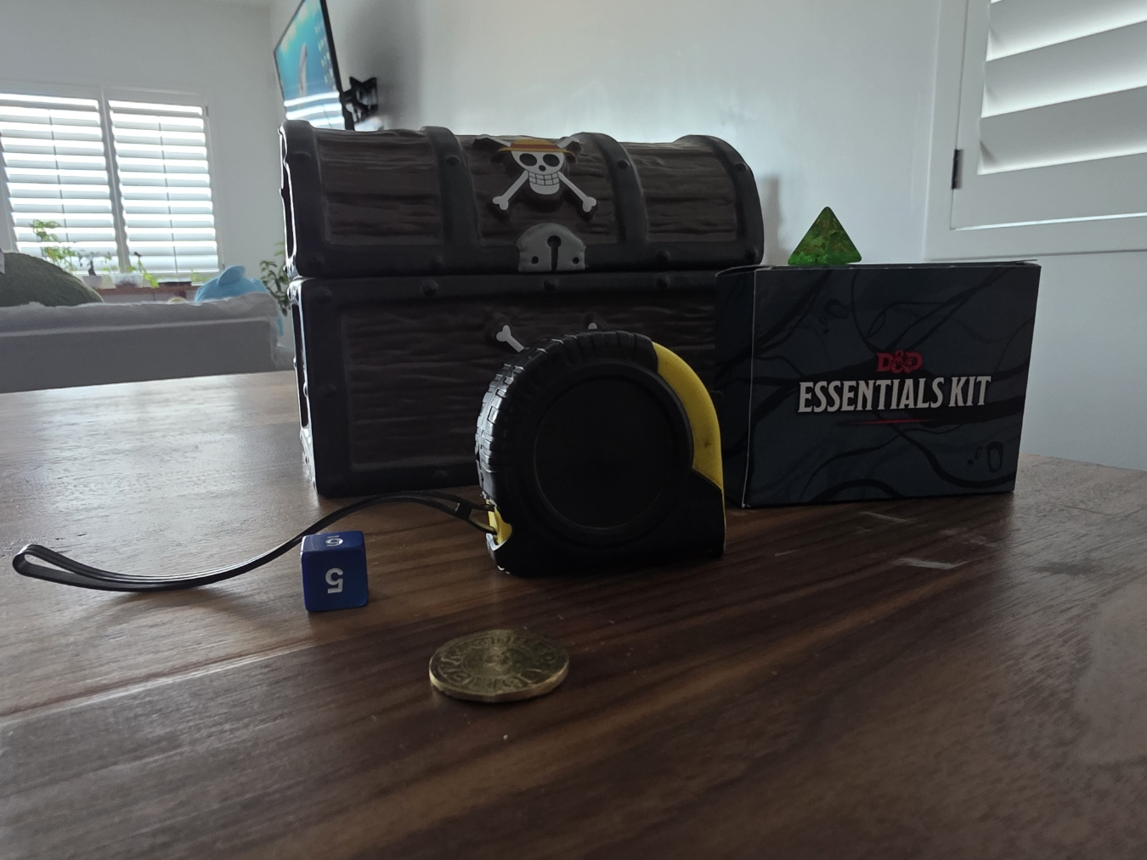
The treasure chest served as the primary complex object in the scene and I built it using multiple simple shapes. The chest base uses a box mesh for the main volume, the lid uses a cylinder mesh rotated and scaled to form a curved top, and the metal bands and lock use thin box meshes with metal material settings. Hinges are created using cylinder meshes placed at the rear of the chest. The tape measure was also built using more than one shape, combining a cylinder mesh for the main body and box meshes for the side panel and tab. Smaller objects such as the coin and dice were built using one object.
Texturing Strategy
To improve realism, I applied textures to multiple objects so the surfaces resembled their materials in the foto. For example, the treasure chest uses a wood texture on the base and lid and a metal texture on the bands and lock. The table surface also uses a wood texture to reinforce the idea that the objects are placed on furniture rather than floating in space. Additional textures like the gold for the coin, and a plastic texture for the die help differentiate objects by material type.
Lighting
Lighting was implemented using the Phong lighting model to create a polished final presentation. I used more than one light source to avoid overly dark regions when the camera moves. A directional light simulates an overall “room light” or general illumination that affects the entire scene. Point lights were used to create localized highlights and improve surface definition on metallic and glossy materials. At least one point light is colored with a warm tone to simulate sunlight or warm indoor lighting and to give the scene more depth. Each light includes ambient, diffuse, and specular components so that surfaces show both base illumination and highlights. Materials were tuned using diffuse color, specular color, and shininess to match the behavior of light from its material.
Object Placement and World Organization
All objects were positioned in the 3D world simulating the perception in the 2d images. The table was used as a stable reference surface, and object Y-positions were adjusted so that items rest naturally on top of the table. The collar of the measuring tape was changed because I thought it looked more aesthetic facing the chest than the die.
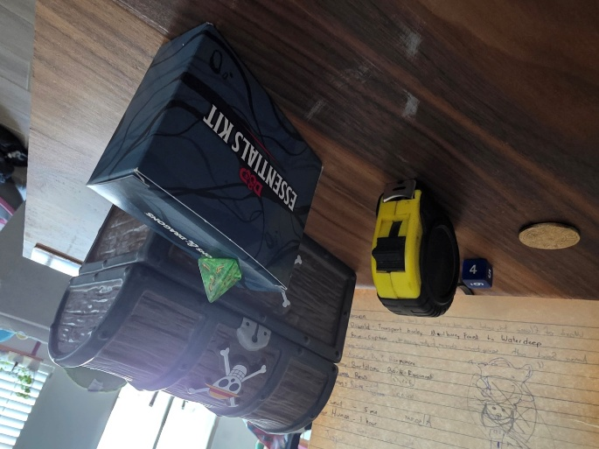
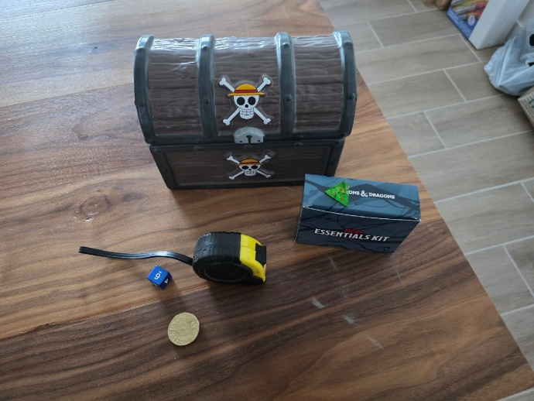

User Navigation and Camera Controls
The scene supports navigation that allows the user to explore objects from multiple viewpoints. Movement is controlled through keyboard input. The WASD keys provide forward, backward, and lateral movement, while the QE keys provide vertical up/down movement. Mouse scroll controls the speed of the camera and pressing the O button will change the perspective. To go back press P button.
Conclusion
This project demonstrates a complete workflow for producing a low-polygon 3D scene in OpenGL: creating object geometry, applying textures and materials, implementing multi-source lighting with Phong shading, placing objects to match a reference image, and enabling full user navigation with keyboard and mouse controls.

